**Inuvialuit Regional Corporation**

**Request for Proposal: Desktop planning study for greenfield residential subdivisions in remote northern communities**

**Due: 15 December**

The Inuvialuit Regional Corporation (IRC) is seeking a planning firm to conduct desktop planning studies for the construction of housing units and related infrastructure, services, and amenities on undeveloped, unsurveyed land in or near Inuvik, Paulatuk, Sachs Harbour and Ulukhaktok.

The successful proponent must:

* Provide a 5-phase community plan for Sites I1, P1, S1, and U1.
* Recommend further field studies that would be required for all sites
* Evaluate options for the provision of energy, water, and sewage services to site I1
* Evaluate transportation, commercial, and service sector needs for Site I1

**Background**

With the signing of the 1984 *Inuvialuit Final Agreement*, Inuvialuit, as represented by IRC were granted fee simple title to over 90,000 square kilometres of lands in the Western Arctic region of the Northwest Territories (“Inuvialuit Lands”). These lands are almost entirely outside of the developed boundaries of communities, and few people live on them at present. The six Inuvialuit communities (Aklavik, Inuvik, Paulatuk, Sachs Harbour, Tuktoyaktuk, and Ulukhaktok) are governed by public municipal governments similar to those in the vast majority of communities anywhere in Canada, and land ownership in the built-up areas of communities is divided between the territorial, municipal, and federal governments and individual and corporate landowners.

All of the Inuvialuit communities have a severe lack of housing and infrastructure. IRC has secured funding to build out housing but is facing a severe shortage of developable land. IRC is evaluating the use of Inuvialuit Lands adjacent to communities for new housing.

**Proposal Format**

Proposal submission

* Proposals must be submitted electronically to the contact below no later than the deadline on the cover of this RFP or modified through an addendum.
* Include all required documentation, drawings, specifications, and cost estimates as outlined in the RFP.

Project Timeline

* Proposals must include a schedule highlighting key milestones. The project must be complete by June 2025.

Experience

* Proposals must highlight the experience of the project team required to complete the project. This includes community planning and energy and utility planning. The project team must have demonstrated in experience working on community planning in northern Indigenous communities, and ideally include Arctic experience.
* Include details of relevant projects completed.

Cost breakdown

* Submit a cost proposal detailing all expenses associated with the project, including the standalone costs of the reports in Appendix 2 and 3, as well as the hourly rates charged by team members.

Evaluation

* Proposals will be evaluated based on factors such as experience, cost, design innovation, and adherence to project goals.
* The selection committee reserves the right to reject any or all proposals and to negotiate terms with selected bidders.
* Preference will be given to Inuvialuit owned businesses and/or proponents and proponents who can clearly demonstrate and agree that employment opportunities will be extended to beneficiaries of the Inuvialuit Final Agreement (“IFA”).

Questions and Clarifications

* All questions and requests for clarifications regarding the RFP must be submitted in writing to the contact listed below by 15 November 2024.
* Responses to inquiries will be provided to all bidders in writing. Contractual Terms: ● The successful bidder will be required to enter into a formal contract with the Inuvialuit Regional Corporation outlining the terms and conditions of the project
* Contract negotiations will commence following the selection of the preferred bidder.

Confidentiality:

* All information provided in response to this RFP is confidential and may not be disclosed to third parties without prior written consent.

**Contact Information: For inquiries and submission of proposals, please contact: Sam Dyck (sdyck@inuvialuit.com)**

**Scope of Work**

Community Plans

The contractor will prepare a community plan consistent with Canadian best practices for urban planning in smaller communities. Site I1 will have lots for 100 houses, and Sites P1, S1, and U1 will have lots for houses each. If the contractor determines any site cannot accommodate the desired number of housing lots, the plan shall be for the as many lots as the site can reasonably accommodate. Should the contractor determine that a site is wholly unsuitable for housing, the contractor shall inform IRC and discuss the potential changes to this Scope of Work. All plans will have sufficient space for infrastructure, utilities, and community amenities proportional to their size, as discussed below. Plans shall facilitate five phase construction over time.

Site selection.

Each site is a general area that IRC assumes is large enough to accommodate the proposed project. The contractor is responsible for selecting appropriate locations for development within the site through a desktop study, considering factors such as elevation, drainage, safety, desirability, and existing infrastructure. IRC assumes that HRDEM and other publicly available geodata is sufficient for this work. To the extent possible, the contractor should consider the impacts of climate change in site selection, including wildlife risk, shoreline erosion, and permafrost degradation.

Where a site is located within the boundaries of a community, the contractor shall assume that municipal zoning bylaws and community plans do not apply, and that there is no requirement for a conventional development permit. Other land use restrictions, such as buffer zones around airports and solid waste sites, will apply.

Housing lots

Housing lots should be able to accommodate a 1,400 square foot single level, single-family house. There should be sufficient space to part two vehicles for each house.

Roads

All roads will be gravel, two lane, that will be sufficient for both vehicle and pedestrian use. Staffing and equipment needs for road maintenance and snow removal are not part of the scope of this plan. Street lighting shall be provided.

Amenities

Each site will have one small playground for every 20 houses, and each house shall be a walkable distance from a playground.

Electricity

Each building will be connected to the power grid, and the plan shall provide space for standard utility poles. The contractor will assume all sites can be connected to the local power grid, although there is a distance of 2.5km from existing lines to the access road currently on Site I1, and IRC does not know what existing infrastructure would need to be upgraded to support Site I1. For site I1, the contractor shall provide a separate energy report detailed below.  
  
Heating energy

For all sites except I1, the contractor will assume each house has a standard fuel oil tank, as is common in northern communities, and there is sufficient space for refueling. For site I1, the contractor shall provide a separate energy report detailed below.

Water and wastewater

For all sites except I1, the contractor will assume that water and wastewater will be provided on a pump-in, pump out system using holding tanks, as is common in smaller northern communities. The staff and equipment requirements for this are out of scope. For site I1, the contractor shall provide a water and wastewater assessment report, as detailed below.

Communications

All buildings will be connected to fibre optic lines. For site I1, the contractor shall provide space for a small cellular tower sufficient to support the community.

Solid Waste

For all sites except I1, each house shall have a roadside animal-proof waste bin, with sufficient space for manual collection. For site I1 there shall be a large animal-proof dumpster placed on a gravel pad adjacent to the road for every 5 houses.

**Appendix 1: Site Locations**

These locations are general areas only and the contractor may develop plans that somewhat exceed the site boundaries below. The primary restriction is that the entire developed area must be Inuvialuit Land. A land ownership and cadastral map is available for the NWT at <https://www.maps.geomatics.gov.nt.ca/HTML5Viewer_Prod/index.html?viewer=ATLAS>

I1

Site I1 is located along the Inuvik-Tuktoyaktuk Highway, immediately outside the municipal boundaries of the Town of Inuvik. The gravel pit located on the site would require further studies to determine the quantity of aggregate remaining and potential for redevelopment. The contractor shall exclude it from planned developments, but may use its access road as part of the development.

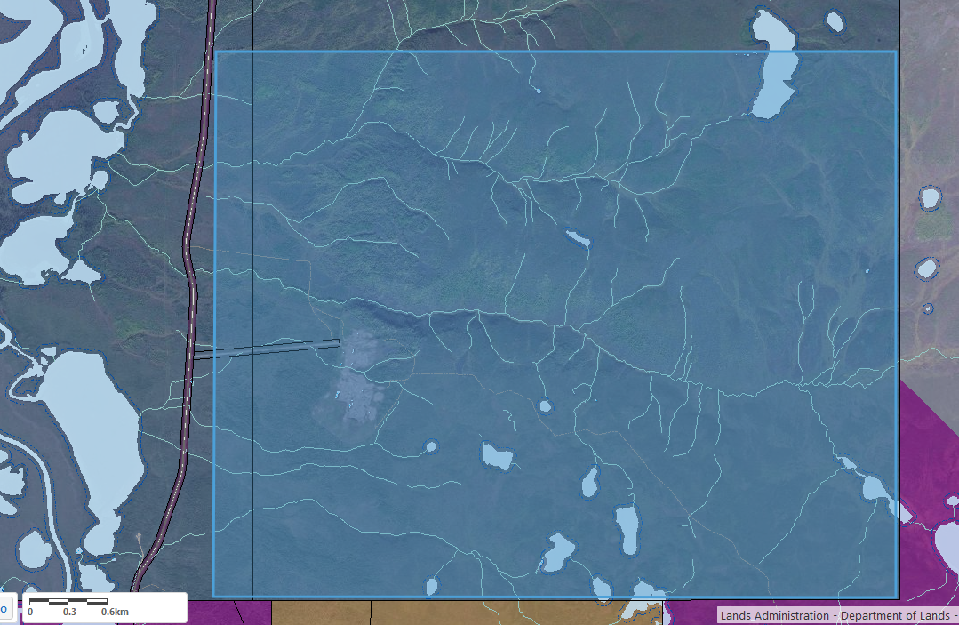

P1

Site P1 is located east of the built up area of Paulatuk. The lake to the south is the community’s water source, and requires an appropriate buffer from development.

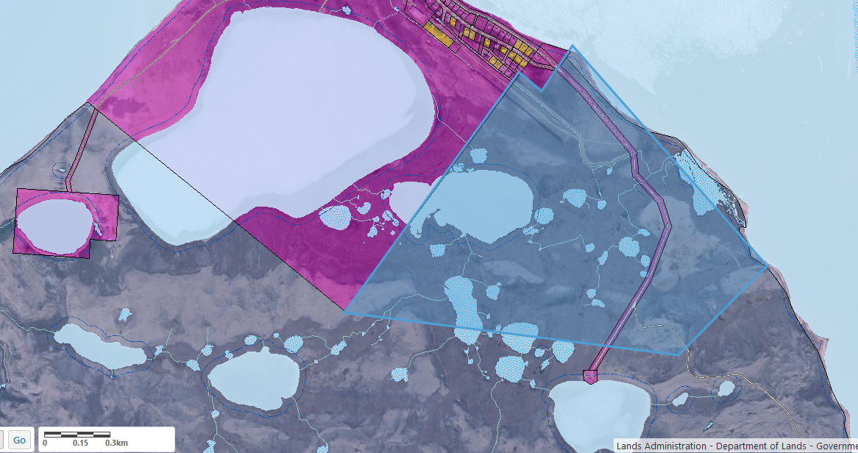

S1

Site S1 is located east of the existing community. An existing house on Inuvialuit Lands visible in satellite imagery shall be given an appropriate buffer similar to other houses in the community. Either the north or south road can be used for access.

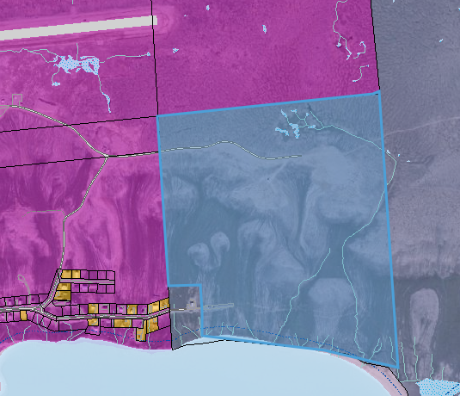

U1

Site U1 is an extension of the existing community to the south along the shoreline.

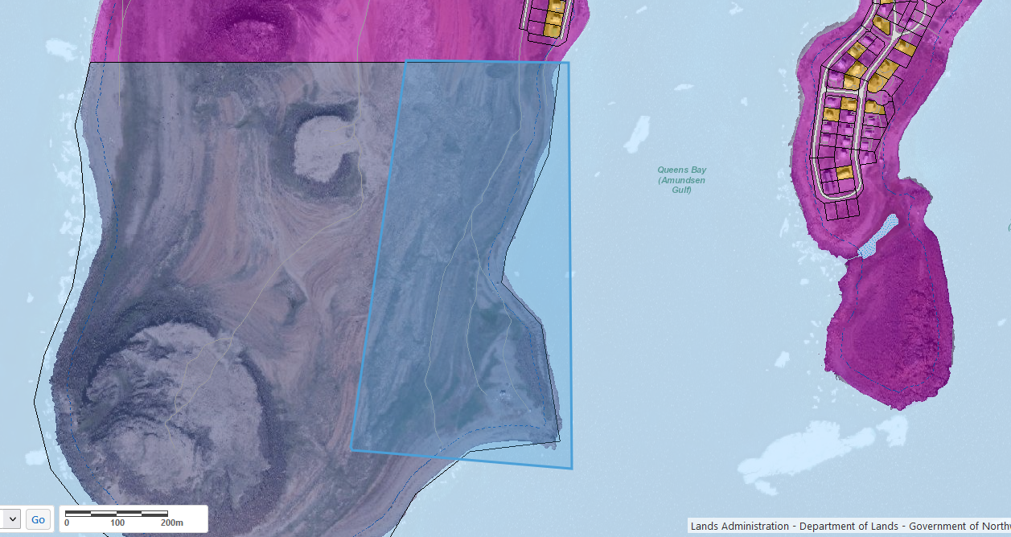

**Appendix 2: Site I1 Supplementary Reports**

**I1 Utilities**

Site I1 is located a considerable distance from the town of Inuvik and its infrastructure. The contractor shall prepare a desktop report evaluating different options for the provision of water, wastewater, and energy to Site I1, including cost estimates for each option.

Water/wastewater

Because Inuvik (and Site I1) are built on continuous permafrost, the core area of the town uses above ground utilidors for water and wastewater, with outlying areas on a pump in/pump out system. Inuvik’s water and waste treatment infrastructure can handle the additional capacity of site I1, however the end of the Utilidor system, as well as the water fill and sewage lagoon dump site, are all approximately 7.5km from the I1 access road.

The contractor will prepare a report evaluating several options for water and wastewater services for Site I1. All sites should provide sufficient water for domestic and commercial use, as well as firefighting.

* Construction of a link to Inuvik’s utilidor system
* Trucked water and wastewater from Inuvik
* Construction of an independent water and wastewater system for I1 closer to the community that complies with the *NWT Waters Act* and *Public Health Act*, to be connected to the community with a utilidor.

Electricity and energy

Site I1 is located 2.5km from the nearest electrical pole. IRC lacks the technical expertise to assess the ability of existing electrical infrastructure in Inuvik. For quick reference a somewhat dated grid diagram for Inuvik can be found in [Appendix D](https://www.inf.gov.nt.ca/sites/inf/files/resources/6.16.11251.van_.r.003_-_gnwt_inuvik_wtg_feasibility_study_final_report_b2_updated.pdf) of this study, with Site I1 being closest to point NK 89-118.

Site I1 is immediately adjacent to the Ikhil pipeline, which upon completion of the [Inuvialuit Energy Security Project](https://irc.inuvialuit.com/inuvialuit-energy-security-project/) could potentially be used to provide gas to I1.

The contractor shall provide a cost benefit analysis for various delivery options for electricity and energy for home heating, evaluating both mature and emergent technologies:

* Connection to the Inuvik Power grid
* Construction of an independent microgrid
* Direct gas connections to individual buildings for heat
* Provision of individual supplies of home heating oil or propane for heat.
* A district energy system

**Appendix 3: Site I1 Transportation, commercial, and services study**

Site I1 is located 9 km from the centre of Inuvik. Past experience with the Reindeer Point subdivision in Tuktoyaktuk has shown that that distance from the core community is makes a subdivision less desirable and creates challenges for residents. The contractor shall prepare a study that evaluates the transportation, commercial, and service sector needs to the I1 site, which can scale as the site is developed in phases.

This should include:

* Determining the community’s need for retail and postal services, and how those can be best provided.
* Determining an adequate level of indoor and outdoor recreation facilities.
* Assessing the need for dedicated early childhood education space
* Examining the need and cost of providing some sort of transportation into Inuvik, both for school children and adults, and what service models could look like.